**Backgrounder: Wildfire management in Saskatchewan**

• The budget for wildfires has decreased by 45 per cent, from $102 million in 2009/10 to $56 million in 2015/16

*Budget for wildfires (in thousands of dollars)*

cid:image001.png@01D1A474.B00B0990

*Retrieved from budget estimates 2009-2016*

<http://finance.gov.sk.ca/budget2015-16/FinanceEstimates2015-16.pdf>

<http://finance.gov.sk.ca/budget2014-15/2014-15Estimates.pdf>

<http://finance.gov.sk.ca/budget2013-14/2013-14Estimates.pdf>

<http://finance.gov.sk.ca/budget2012-13/2012-13Estimates.pdf>

<http://finance.gov.sk.ca/budget2011-12/2011-12Estimates.pdf>

<http://finance.gov.sk.ca/budget2010-11/2010-11Estimates.pdf>

<http://finance.gov.sk.ca/budget2009-10/Budget200910Estimates.pdf>

• 38 firefighter and 40 tower observer positions were eliminated over the last several years, according to the SGEU.

<http://www.sgeu.org/public/images/News_Releases/20151208-Government_review_of_wildfire_crisis.pdf>

•  Due to below average snowfall and low spring rain levels, the majority of  Saskatchewan is either at a “high” or “extreme” risk for wildfires, according to the latest update from the Government of Saskatchewan’s Wildfire Management Branch.

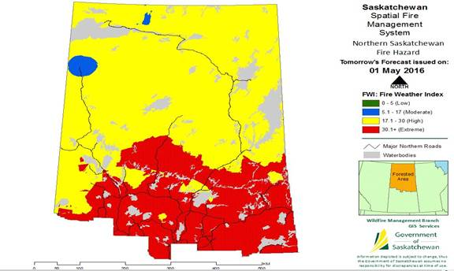

Map retrieved from: <http://www.environment.gov.sk.ca/Default.aspx?DN=3828f5ca-06cb-420a-bd19-dfed4785c99e>

Forest Fringe fire hazard map:

<http://www.environment.gov.sk.ca/Default.aspx?DN=5e4cf88a-8c35-4f56-a636-d6336aa905d1>

Southern Saskatchewan fire hazard map:

<http://www.environment.gov.sk.ca/Default.aspx?DN=f436a478-b527-4015-b314-86b14d2fe73b>

-30-

For more information, contact:

Doyle Fox, NDP caucus

306-787-0974

[dfox@ndpcaucus.sk.ca](https://exchange.saskndp.ca/owa/redir.aspx?SURL=SyBbJyAFR7SHRk1LACoG33GWzHEcAfKmhoFKaQ58__ybJcS-girTCG0AYQBpAGwAdABvADoAZABmAG8AeABAAG4AZABwAGMAYQB1AGMAdQBzAC4AcwBrAC4AYwBhAA..&URL=mailto%3adfox%40ndpcaucus.sk.ca)