Evaluation of Arthrospira (Spirulina) platensis growth on cheese whey in the context of circular economy
Vasiliki Athanasiadou^{1*}, Eleftheria E. Klontza¹, Petros Dimitriou-Christidis^{2,3}, Michalis Fountoulakis¹ and Demetris F. Lekkas¹
Rationale: Cultivation of microalgae using wastewater could be considered as a cost-effective treatment method, while providing the necessary nutrients to for the production of high-value biomass. The potential use of cheese whey for Arthrospira (spirulina) platensis cultivation could provide a sustainable solution aligned with circular economy principles for the treatment of dairy industry wastewater, in regions such as North Aegean (Greece).
Aim: The aim of this research is to investigate the parameters that influence the growth of Arthrospira platensis biomass on whey rich solutions, as a substitute to chemical nutrient feeds, according to the practices of circular economy and sustainable development.
Methods: Specifically, the effect of `different whey dilution ratios and irradiation conditions on biomass productivity, nutrient consumption and COD removal were examined in batch experiments.
Results: show that the concentration of 10% (v/v) cheese whey exhibited the best performance in both experimental illumination sets; continuous and light/dark cycles while providing the necessary nutrients to for the production of high-value biomass.
Conclusions & Outlook: The potential use of cheese whey for Arthrospira (spirulina) platensis cultivation could provide a sustainable solution aligned with circular economy principles for the treatment of dairy industry wastewater, in regions such as North Aegean (Greece).

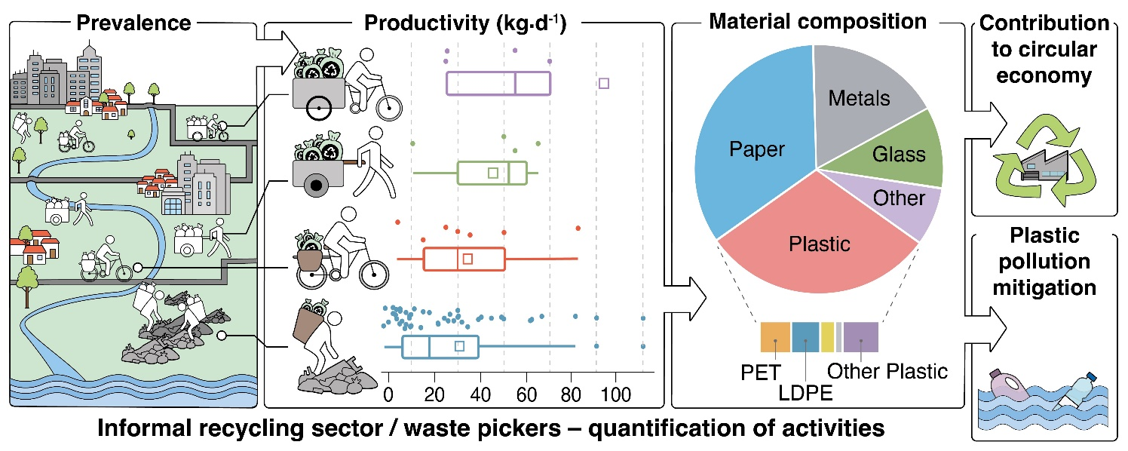

¹Waste Management Laboratory, Department of Environment, University of the Aegean, University Hill, 81100 Mytilene, Greece
²Earth Space Technical Ecosystem Enterprises SA
³Independent environmental consultant
*Corresponding author - email: envm21041@env.aegean.gr

Acknowledgements: We acknowledge support of this work by the project “Center of Sustainable and Circular Bioeconomy [Aegean_BIOECONOMY]” (MIS 5045851) which is implemented under the Action “Reinforcement of the Research and Innovation Infrastructure”, funded by the Operational Programme "Competitiveness, Entrepreneurship and Innovation" (NSRF 2014-2020) and co-financed by Greece and the European Union (European Regional Development Fund).
Data availability: We acknowledge support of this work by the project “Center of Sustainable and Circular Bioeconomy [Aegean_BIOECONOMY]” (MIS 5045851) which is implemented under the Action “Reinforcement of the Research and Innovation Infrastructure”, funded by the Operational Programme "Competitiveness, Entrepreneurship and Innovation" (NSRF 2014-2020) and co-financed by Greece and the European Union (European Regional Development Fund).
Funding: We acknowledge support of this work by the project “Center of Sustainable and Circular Bioeconomy [Aegean_BIOECONOMY]” (MIS 5045851) which is implemented under the Action “Reinforcement of the Research and Innovation Infrastructure”, funded by the Operational Programme "Competitiveness, Entrepreneurship and Innovation" (NSRF 2014-2020) and co-financed by Greece and the European Union (European Regional Development Fund).
Author Credits: We acknowledge support of this work by the project “Center of Sustainable and Circular Bioeconomy [Aegean_BIOECONOMY]” (MIS 5045851) which is implemented under the Action “Reinforcement of the Research and Innovation Infrastructure”, funded by the Operational Programme "Competitiveness, Entrepreneurship and Innovation" (NSRF 2014-2020) and co-financed by Greece and the European Union (European Regional Development Fund).
References
[1] Aguado J., Arsuaga J.M., Arencibia A., Lindo M. and Gascón V. (2009), Aqueous heavy metals removal by adsorption on amine-functionalized mesoporous silica, Journal of Hazardous Materials, 163, 213-221.
[2] Allen S.J., McKay G. and Khader K.Y.H. (1989), Intraparticle diffusion of a basic dye during adsorption onto Sphagnum Peat, Environmental Pollution, 56, 39-50.
[3] Areco M.M. and Afonso M.S. (2010), Copper, zinc, cadmium and lead biosorption by Gymnogongrus torulosus. Thermodynamics and kinetics studies, Colloids and Surfaces B: Biointerfaces, 81, 620-628.
[4] Axtell N.R., Sternberg S.P.K. and Claussen K. (2003), Lead and nickel removal using Microspora and Lemna minor, Bioresource Technology, 89, 41-48.
[5] Bhattacharya A.K., Mandal S.N., and Das S.K. (2006), Adsorption of Zn (II) from aqueous solution by using different adsorbents, Chemical Engineering Journal, 123, 43-51.
[6] Bulut Y. and Tez Z. (2007), Adsorption studies on ground shells of hazelnut and almond, Journal of Hazardous Materials, 149, 35-41.
[7] Çalışkan N., Kul A.R., Alkan S., Gogut E.G. and Alacabey I. (2011), Adsorption of zinc (II) on diatomite and manganese-oxide-modified diatomite: A kinetic and equilibrium study, Journal of Hazardous Materials, 193, 27-36.
[8] Cheremisinoff P.N. (1995), Handbook of Water and Wastewater Treatment Technology, Marcel Dekker Inc., New York.

