Evaluation of Arthrospira (Spirulina) platensis growth on cheese whey in the context of circular economy
Vasiliki Athanasiadou^{1*}, Eleftheria E. Klontza¹, Petros Dimitriou-Christidis^{2,3}, Michalis Fountoulakis¹ and Demetris F. Lekkas¹
Rationale: Cultivation of microalgae using wastewater could be considered as a cost-effective treatment method, while providing the necessary nutrients to for the production of high-value biomass. The potential use of cheese whey for Arthrospira (spirulina) platensis cultivation could provide a sustainable solution aligned with circular economy principles for the treatment of dairy industry wastewater, in regions such as North Aegean (Greece). Aim: The aim of this research is to investigate the parameters that influence the growth of Arthrospira platensis biomass on whey rich solutions, as a substitute to chemical nutrient feeds, according to the practices of circular economy and sustainable development. Methods: Specifically, the effect of `different whey dilution ratios and irradiation conditions on biomass productivity, nutrient consumption and COD removal were examined in batch experiments. Results: show that the concentration of 10% (v/v) cheese whey exhibited the best performance in both experimental illumination sets; continuous and light/dark cycles while providing the necessary nutrients to for the production of high-value biomass. Conclusions & Outlook: The potential use of cheese whey for Arthrospira (spirulina) platensis cultivation could provide a sustainable solution aligned with circular economy principles for the treatment of dairy industry wastewater, in regions such as North Aegean (Greece).

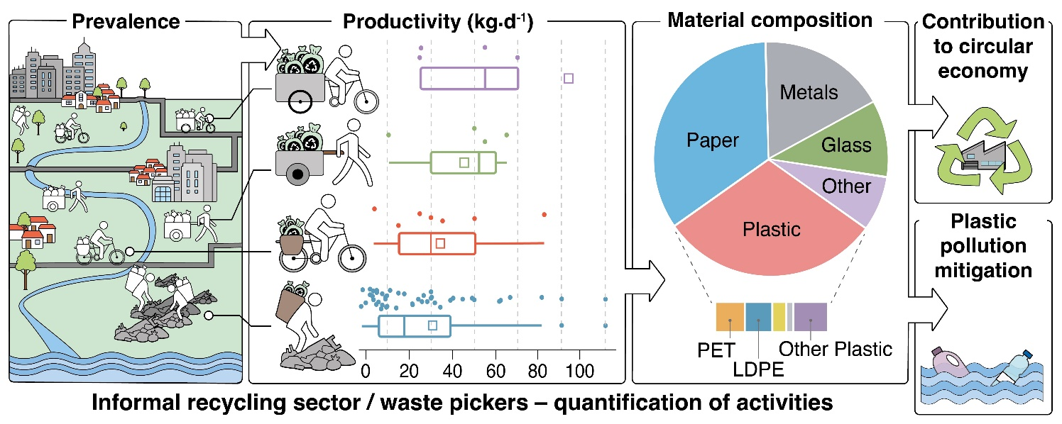

¹Waste Management Laboratory, Department of Environment, University of the Aegean, University Hill, 81100 Mytilene, Greece
²Earth Space Technical Ecosystem Enterprises SA
³Independent environmental consultant
*Corresponding author - email: envm21041@env.aegean.gr

- Introduction
Environmental issues like climate change, ecosystem degradation, and population expansion, together with other global issues, are important drivers of new methods of production and consumption for the protection of the planet's ecological boundaries. Circular and resource-efficient economic models, which consider the entire material cycle to promote reuse as well as waste reduction and efficient resource utilization, are increasingly replacing linear economic models based on production-consumption-disposal systems [1]. The circular economy model [2] seeks to maintain a balance between economic and environmental issues. The upshot will be the revitalization of industries, the modernization of primary production systems, improved environmental protection, and an increase in biodiversity. By highlighting the importance of renewable resources and biotechnologies in sustainable development and encouraging the Regions and agencies to develop innovations in the bioeconomy, the European Union has set the main axes for the formation of an operational group and a road map. These new industries, which now make up 9% of all employment in the EU, have enormous development potential and the capacity to change the economic environment through collaborations between enterprises and organizations.
- Materials and Methods
2.1 Microorganisms and culture medium
Arthrospira (Spirulina) platensis strain PCC8005 obtained Pasteur Institute, France has been selected for this research . The stocks used in the experiments have been prepared in the Waste Management Laboratory of the Department of Environment of the University of the Aegean. The stocks are kept in Erlenmeyer flasks under the following conditions: Temperature 28 ○C, continuous lighting 24 hours with an 8-W led lamp and 680 lm, with liquid medium Cogne Modified Zarrouk (CMZM) [3] CMZM composition is 1.0 g L⁻¹ NaCl, 0.03 g L⁻¹ CaCl_{2,} 1.0 g L⁻¹ K₂SO_{4,} 0.08 g L⁻¹ MgSO₄ - 7 H₂O, 0.5 g L⁻¹ K₂HPO_{4,} 2.5 g L⁻¹ NaNO_{3,} 10.5 g L⁻¹ NaHCO_{3,} 7.6 g L⁻¹ Na₂CO_{3,} 0.08 g L⁻¹ EDTA, 0.01 g L⁻¹ FeSO₄ - 7 H₂O. The trace elements solution also contained 0.23 g L⁻¹ MnCl₂·4H₂O, 0.11 g L⁻¹ ZnSO₄·7 H₂O and 0.03 g L⁻¹ CuSO₄. The experimental sets were conducted in continuous illumination and light/dark cycles using the Zarrouk medium as control while for the experimental trials, diluted cheese whey with tap water was used.
2.2 Clarification of cheese whey for the growth of Arthrospira platensis
Cheese whey is a nutrient-rich waste substrate that appears to have the potential in the context of the circular economy for the production of biomass. This material is rich in phosphorus, organic compounds, and nitrogen, making it a promising nutrient; however, there are some limitations that result from its increased turbidity obstructing light to pass through. Another possible limitation is the development of pathogens that can lead to competition for the consumption of nutrients [4].
- Results and Discussion
3.1 Adaption of Arthrospira platensis to growth conditions
Within the first 24 hours, all cultures went through an adaptation period. This was expected, since an inoculum from a standard growth medium was used and it took some time for Arthrospira platensis to adapt to the new growth conditions with cheese whey. Adaptation is an important phase for cyanobacteria acclimatization and significantly affects the performance. However, after the adaptation, cyanobacteria are consuming nutrients and multiply with respect to most favourable conditions and nutrient availability; therefore, the adaptation phase will have no significant impact on large scale applications, as the conditions will not be altered during biomass production.
3.2 Cultivation of Arthrospira platensis under continuous illumination
Optical density (OD) and VSS were used to monitor biomass production. Turbidity was observed in the OD measurements which - as expected - increases with higher whey concentration, as also observed by Nazos et al. (2023) as it is related to the solids that are present in the solution obstructing light to pass through.
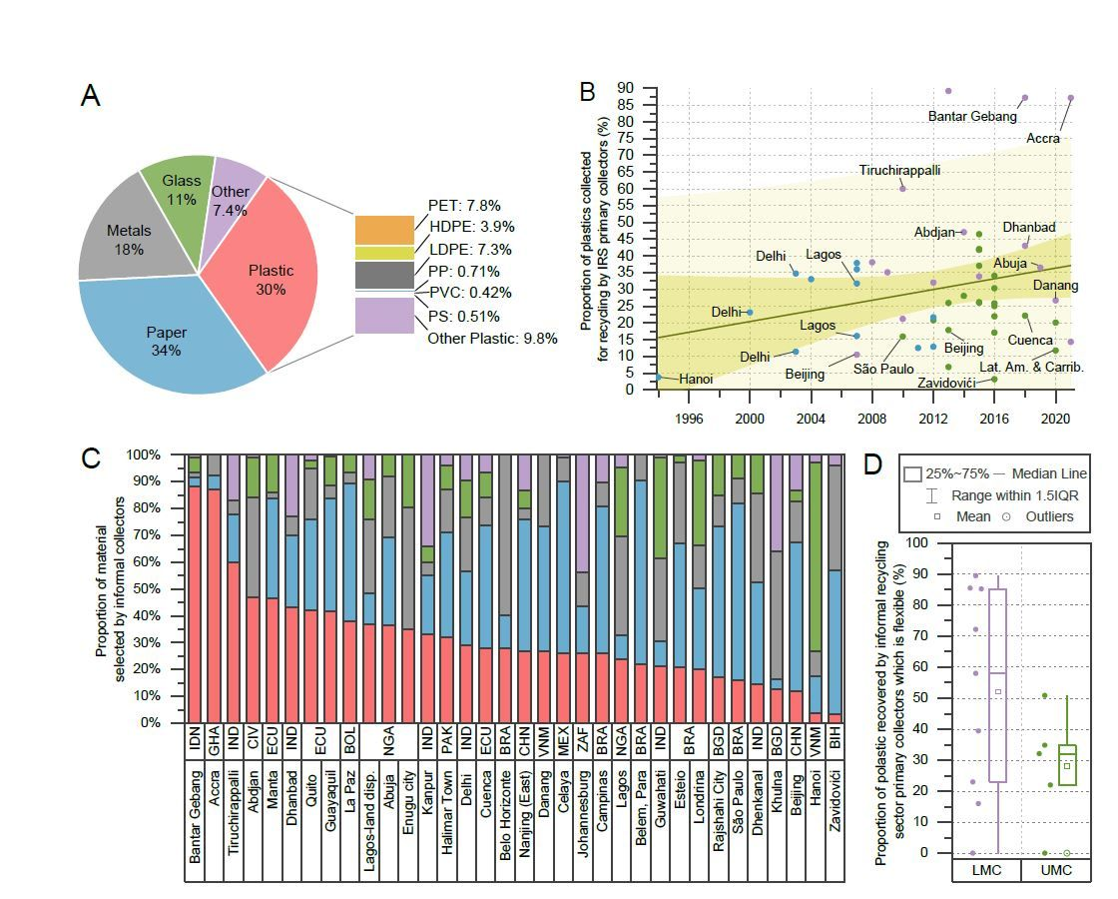
Figure 1. (A) List here main findings. Effect of pH for the removal of Pb (II) onto diatomite. Effect of pH for the removal of Pb (II) onto diatomite. Effect of pH for the removal of Pb (II) onto diatomite. (B) Effect of pH for the removal of Pb (II) onto diatomite. Effect of pH for the removal of Pb (II) onto diatomite. (C) Effect of pH for the removal of Pb (II) onto diatomite. (D) Effect of pH for the removal of Pb (II) onto diatomite. Source: This work / After / Adapted from. Abbreviations: PVC: Polyvinylchloride.
3.1 Adaption of Arthrospira platensis to growth conditions
Within the first 24 hours, all cultures went through an adaptation period. This was expected, since an inoculum from a standard growth medium was used and it took some time for Arthrospira platensis to adapt to the new growth conditions with cheese whey. Adaptation is an important phase for cyanobacteria acclimatization and significantly affects the performance. However, after the adaptation, cyanobacteria are consuming nutrients and multiply with respect to most favourable conditions and nutrient availability; therefore, the adaptation phase will have no significant impact on large scale applications, as the conditions will not be altered during biomass production.
3.2 Adaption of Arthrospira platensis to growth conditions
Within the first 24 hours, all cultures went through an adaptation period. This was expected, since an inoculum from a standard growth medium was used and it took some time for Arthrospira platensis to adapt to the new growth conditions with cheese whey. Adaptation is an important phase for cyanobacteria acclimatization and significantly affects the performance. However, after the adaptation, cyanobacteria are consuming nutrients and multiply with respect to most favourable conditions and nutrient availability; therefore, the adaptation phase will have no significant impact on large scale applications, as the conditions will not be altered during biomass production.
3.1 Adaption of Arthrospira platensis to growth conditions
Within the first 24 hours, all cultures went through an adaptation period. This was expected, since an inoculum from a standard growth medium was used and it took some time for Arthrospira platensis to adapt to the new growth conditions with cheese whey. Adaptation is an important phase for cyanobacteria acclimatization and significantly affects the performance. However, after the adaptation, cyanobacteria are consuming nutrients and multiply with respect to most favourable conditions and nutrient availability; therefore, the adaptation phase will have no significant impact on large scale applications, as the conditions will not be altered during biomass production.
- Conclusions & Outlook
In the present study, different concentrations of non-aseptic cheese whey were tested, at different environmental conditions (several pH and illumination periods) while keeping constant temperature 28 ○C, for the growth of Arthrospira platensis strain PCC8005. The highest biomass production of all experiments occurred at 12-h dark/light photoperiod, 10.5 pH and 10% (v/v) cheese whey concentration. However, further research is proposed to optimize the conditions for the cultivation of Arthrospira platensis using cheese whey - an agrowaste biproduct from cheese production. Analysis of the biochemical composition of the produced biomass, which is crucial to determine whether the production of certain metabolites of economic interest is required. An important step would also be the transition to pilot and/or industrial application. Overall, it has been shown that the non-aseptic cheese whey can be utilized as a substrate to reduce the production cost of Arthrospira while reducing the environmental impact of cheese factories and promoting circular economy concepts.
Acknowledgements: We acknowledge support of this work by the project “Center of Sustainable and Circular Bioeconomy [Aegean_BIOECONOMY]” (MIS 5045851) which is implemented under the Action “Reinforcement of the Research and Innovation Infrastructure”, funded by the Operational Programme "Competitiveness, Entrepreneurship and Innovation" (NSRF 2014-2020) and co-financed by Greece and the European Union (European Regional Development Fund).
Data availability: We acknowledge support of this work by the project “Center of Sustainable and Circular Bioeconomy [Aegean_BIOECONOMY]” (MIS 5045851) which is implemented under the Action “Reinforcement of the Research and Innovation Infrastructure”, funded by the Operational Programme "Competitiveness, Entrepreneurship and Innovation" (NSRF 2014-2020) and co-financed by Greece and the European Union (European Regional Development Fund).
Funding: We acknowledge support of this work by the project “Center of Sustainable and Circular Bioeconomy [Aegean_BIOECONOMY]” (MIS 5045851) which is implemented under the Action “Reinforcement of the Research and Innovation Infrastructure”, funded by the Operational Programme "Competitiveness, Entrepreneurship and Innovation" (NSRF 2014-2020) and co-financed by Greece and the European Union (European Regional Development Fund).
Author Credits: We acknowledge support of this work by the project “Center of Sustainable and Circular Bioeconomy [Aegean_BIOECONOMY]” (MIS 5045851) which is implemented under the Action “Reinforcement of the Research and Innovation Infrastructure”, funded by the Operational Programme "Competitiveness, Entrepreneurship and Innovation" (NSRF 2014-2020) and co-financed by Greece and the European Union (European Regional Development Fund).
References
[1] Aguado J., Arsuaga J.M., Arencibia A., Lindo M. and Gascón V. (2009), Aqueous heavy metals removal by adsorption on amine-functionalized mesoporous silica, Journal of Hazardous Materials, 163, 213-221.
[2] Allen S.J., McKay G. and Khader K.Y.H. (1989), Intraparticle diffusion of a basic dye during adsorption onto Sphagnum Peat, Environmental Pollution, 56, 39-50.
[3] Areco M.M. and Afonso M.S. (2010), Copper, zinc, cadmium and lead biosorption by Gymnogongrus torulosus. Thermodynamics and kinetics studies, Colloids and Surfaces B: Biointerfaces, 81, 620-628.
[4] Axtell N.R., Sternberg S.P.K. and Claussen K. (2003), Lead and nickel removal using Microspora and Lemna minor, Bioresource Technology, 89, 41-48.
[5] Bhattacharya A.K., Mandal S.N., and Das S.K. (2006), Adsorption of Zn (II) from aqueous solution by using different adsorbents, Chemical Engineering Journal, 123, 43-51.
[6] Bulut Y. and Tez Z. (2007), Adsorption studies on ground shells of hazelnut and almond, Journal of Hazardous Materials, 149, 35-41.
[7] Çalışkan N., Kul A.R., Alkan S., Gogut E.G. and Alacabey I. (2011), Adsorption of zinc (II) on diatomite and manganese-oxide-modified diatomite: A kinetic and equilibrium study, Journal of Hazardous Materials, 193, 27-36.
[8] Cheremisinoff P.N. (1995), Handbook of Water and Wastewater Treatment Technology, Marcel Dekker Inc., New York.

