The Implementation of Daily Performance Monitoring in Enhancing Adab Education (Calibri, 14- Bold)

^{1*}First Author, ²Second Author, ³Third Author (Calibri, 12-Bold)
¹(Department, College/ University Name, Address, Country Name, Email) (Calibri, 12)
²(Department, College/ University Name, Address, Country Name, Email) (Calibri, 12)
³(Department, College/ University Name, Address, Country Name, Email) (Calibri, 12)
*corresponding author (if the author is more than one)

ABSTRACT  Purpose: This is where you explain ‘why’ you undertook this study. If you present new or novel research, explain the problem you have solved. If you are building upon previous research, briefly explain why you felt it was important to do so. This is your opportunity to let readers know why you chose to study this topic or problem and its relevance. Let them know what your key argument or main finding is.  Study Design/Methodology/Approach: This is ‘how’ you did it. Let readers know exactly what you did to reach your results. For example, did you undertake interviews? Did you carry out an experiment in the lab? What tools, methods, protocols, or datasets did you use?  Findings: Here, you can explain ‘what’ you found during your study, whether it answers the problem you set out to explore, and whether your hypothesis was confirmed. You need to be clear and direct and give exact figures rather than generalise. It’s important not to exaggerate or create an expectation your paper won’t fulfil. Research limitations/implications – Limitations are shown in the sites in an area of restricted technologies in a developing country.  Originality/value: This is your opportunity to provide readers with an analysis of the value of your results. It’s a good idea to ask colleagues whether your analysis is balanced and fair; again, it’s important not to exaggerate. You can also conjecture what future research steps could be. (Calibri, 12 - 150 - 250 words) | ARTICLE HISTORY  Received:  01-05-2025  Rev. Req:  15-05-2025  Accepted:  30-05-2025  (Calibri, 12)  KEYWORDS  Education Values;  Islamic Education,  Adab Education. (Calibri, 12)
Example: Purpose – This paper aims to explore the leadership styles of principals of Islamic High Schools (IHS), specifically how well the principals motivate, mobilize, direct, and evaluate teachers’ performance to achieve students’ academic attainment. Design/methodology/approach – A qualitative study with a multi-site case study was conducted at three IHS in Korea, East Java, Indonesia. Principals of IHS were interviewed, as were administrators and teachers, to confirm the principals’ performances and the results of their leadership on professional management, school policies, procedures, and the implementation of the schools’ dynamic and students’ academic attainments. Findings – This study revealed that IHS principals are the central figures in Islamic schools. In particular, implementation of leadership styles is specified as motivating: intensive communications, incentives, and transparent administrative management; mobilizing: giving opportunities to study for higher degrees, workshops, internet facilities, and rewards; directing: additional teaching hours, scholarships, briefings, and cooperation with other agencies; and evaluating: class visits, personal meetings, encouraging participation, communicating with madrasah committees, collaborating with foreign universities, and conducting research to improve learning. Effective leadership styles increase students’ academic attainments. Research limitations/implications – Limitations are shown in the sites in an area of restricted technologies in a developing country. Originality/value – This study develops its setting and orientation by integrating Islamic and global values in education management. It shows the prominent role of IHS principals, as the specific cases exemplify leadership and management at secondary schools. --Example-- (12 Times New Roman)

- INTRODUCTION (Calibri, 12 Bold)
The introduction of the paper should explain the nature of the problem, previous work, purpose, and the contribution of the paper. The contents of each section may be provided to understand easily about the paper. 80% referral is mandatory from journals, the remaining 20% can be from books, etc. from the last 10th issue (for example, your manuscript will be published in 2020, then the max reference is published in 2010). (Calibri, 12).
- LITERATURE REVIEW
The literature review should provide a comprehensive and critical overview of previous research relevant to the study. Authors are expected to synthesize key findings from peer-reviewed sources, identify theoretical frameworks, highlight research gaps, and justify the novelty of the current study. The review must be structured thematically or chronologically, use recent and relevant references (preferably within the last 5–10 years), and adhere to international academic citation standards (Smith, 2023, APA 7th Edition). Authors should avoid merely summarizing sources; instead, they must critically evaluate the methodologies, findings, and contributions of prior studies to build a solid foundation for the research problem (Calibri, 12)..
- METHOD (Calibri, 12 Bold)
This section describes when the experiment has been performing. The researcher explains the experimental design, equipment, data collection methods, and types of control [the core content of this research method is more or less the same as in the thesis and dissertation, but the summary is not as complete as in the thesis and dissertation]. If the experiment is carried out in the field, the writer describes the research area, location, and also describes the work carried out. The general rule to remember is that this section should be detailed and precise so that the reader has the necessary knowledge and techniques for publication. The sequence is a type of research, reasons for taking at the location, data sources and informants, data collection techniques, data analysis, and checking the validity of the data carried out. Finally, the focus of the research is almost the same as in the introduction of the research objectives, but in this research, the method is more specific. (Calibri, 12).
- RESULT AND DISCUSSION (Calibri, 12 Bold)
RESULT (Calibri, 12 Bold)
For quantitative research, Results of data analyses can be presented in tables, graphs, figures or any combination of the three. Tables, graphs, or figures should not be too long, too large, nor too many. The writer is advised to use decent variation in presenting tables, graphs, or verbal description. All displayed tables and graphs should be referred to in the text. The format of tables is shown in Table 1. Tables do not use column (vertical) lines and row (horizontal) lines are used only for the head and tail of the table. The font of the table entry may be reduced. Figures in the table should not be over-repeated in the narration before or after the table. (Calibri, 12)
Figures are written in the following format. For scripts written in Indonesian, thousands are written out using periods; for example: 1200300 is written as 1.200.300. Decimal points are marked with a comma followed by two number digits; e.g.: 12,34. For figures lower than 1, the zero must be written; e.g.: 0,12. For scripts written in English, thousands are marked using commas; e.g.: 1200300 is written as 1,200,300. Decimal points are marked with a period followed by two number digits; e.g.: 12.34. For figures lower than 1, the zero is not needed; e.g.: .12. (Calibri, 12)
For mathematical symbols or notations, the alphabet is italicized, but Greek letters are written upright using the correct symbols. The equal sign is given a punch space before and after; e.g. (English format): r = .456; p = .008. For statistical values having degrees of freedom such as t, F, atau Z, the figure of the degree of freedom is written in braces such as t(52) = 1.234; F(1, 34) = 4.567. Statistical calculation for hypothesis testing should be completed with effect sizes; for example: the t-test using cohen’s d, the F-test using partial eta squared, or other post-hoc tests in line with the references under consideration. (Calibri, 12)
For qualitative research, findings should substantially be presented in a condensed report based on the results of a rigorous qualitative data analysis. Tables, diagrams, charts, or other data visualizations maybe presented to facilitate ease of reading. Authentic evidence from empirical data (e.g., excerpts from interview transcripts, field-notes, documents) should be presented in a reasonable number of texts that do not surpass the authors’ statements on their findings. To ensure a high-quality product, diagrams and lettering MUST be either computer-drafted or drawn using ink. (Calibri, 12)
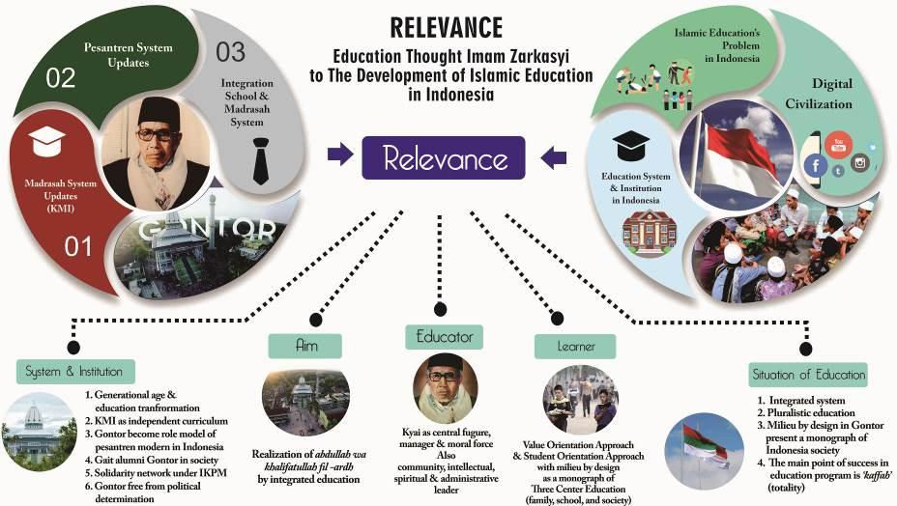
Figure 1. The Scheme of Relevance to The Development of
Islamic Education in Indonesia (Exp for diagram)
Figure captions appear below the figure, are flush left, and are in lower case letters. When referring to a figure in the body of the text, the abbreviation "Fig." is used. Figures should be numbered in the order they appear in the text. (Calibri, 12)
Tabel 1. Composition of Curriculum Structure of
Islamic Law (Exp for table)
No | Course Group
1. | Personality Development Course (MPK)
2. | Science and Skills Course (MKK)
3. | Working Skills Course (MKB)
4. | Working Behavior Course (MPB)
5. | Community Life Courses (MBB)
Table captions appear centered above the table in upper and lower case letters. When referring to a table in the text, no abbreviation is used and "Table" is capitalized. Figures and tables should be included in the running text itself. (Calibri, 12)
Discussion (Calibri, 12 Bold)
Intended to give interpretation and meaning to the results of the study in accordance with the theories and references that are used. It is not merely used to present findings. Interpretation should be enriched with referencing, comparing, or contrasting with findings of previous research published in reputable, not predatory, journal. It is advisable to integrate findings into collection of theories or established knowledge, development of a new theory, or modification of existing theories. Implications of the research findings are given.
- CONCLUSION (Calibri, 12 Bold)
A conclusion section must be included and should indicate clearly the advantages, limitations, and possible applications of the paper. Although a conclusion may review the main points of the paper, do not replicate the abstract as the conclusion. A conclusion might elaborate on the importance of the work or suggest applications and extentions. (Calibri, 12).
- ACKNOWLEDGEMENTS (Calibri, 12 Bold)
An acknowledgement section may be presented after the conclusion, if desired. (Calibri, 12)
- REFERENCES (Calibri, 12 Bold)
- M Ozaki, Y. Adachi, Y. Iwahori, and N. Ishii, Application of fuzzy theory to writer recognition of Chinese characters, International Journal of Modelling and Simulation, 18(2), 1998, 112-116.
- R.E. Moore, Interval analysis (Englewood Cliffs, NJ: Prentice-Hall, 1966).
- P.O. Bishop, Neurophysiology of binocular vision, in J.Houseman (Ed.), Handbook of physiology, 4 (New York: Springer-Verlag, 1970) 342-366.
pA reference list MUST be included using the following information as a guide. Only cited text references are included. Each reference is referred to in the text by a number enclosed in a square bracket (i.e., [3]). References must be numbered and ordered according to where they are first mentioned in the paper, NOT alphabetically. Reference must use reference manager, exp: mendeley, endnote, etc. in APA style format.

Writing Method Examples form Journal Papers, Books, Chapter in Books, Theses and Proceedings Papers follow:

Journal Papers:

- M Ozaki, Y. Adachi, Y. Iwahori, and N. Ishii, Application of fuzzy theory to writer recognition of Chinese characters, International Journal of Modelling and Simulation, 18(2), 1998, 112-116. (Calibri, 12)

Books:

- R.E. Moore, Interval analysis (Englewood Cliffs, NJ: Prentice-Hall, 1966). (Calibri, 12)

Note that the title of the book is in lower case letters and italicized. There is no comma following the title. Place of publication and publisher are given.

Chapters in Books:

- P.O. Bishop, Neurophysiology of binocular vision, in J.Houseman (Ed.), Handbook of physiology, 4 (New York: Springer-Verlag, 1970) 342-366. (Calibri, 12)

Note that the place of publication, publisher, and year of publication are enclosed in brackets. Editor of book is listed before book title.
Theses:
- D.S. Chan, Theory and implementation of multidimensional discrete systems for signal processing, doctoral diss., Massachusetts Institute of Technology, Cambridge, MA, 1978. (12)

Proceedings Papers:
- W.J. Book, Modelling design and control of flexible manipulator arms: A tutorial review, Proc. 29th IEEE Conf. on Decision and Control, San Francisco, CA, 1990, 500-506. (Calibri, 12)

